**Visualizing Solid Shapes**

# Plane Shapes:

* + Plane shapes have two measurements like length and breadth.
  + For example: Circle, Square, Triangle, Rectangle and Quadrilaterals are plane figures.
  + Plane figure are of two – dimensions **(2 – D).**

The cube, the cuboid, the sphere, the cylinder, the cone, the pyramid are examples of solid shapes.

# Solid Shapes:

* + Solid shapes have three measurements like length, breadth and height or depth.
  + For example: Cube, Cuboid, Cone, Cylinder, Sphere, Pyramid are Solid figures.
  + Solid figures are of three – dimensions **(3 – D).**

# 3D Shapes:

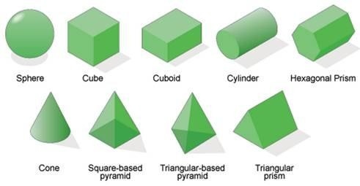

* + Each side of a solid has a surface called **a face.**
  + Two faces meet at a line segment called **an edge.**
  + Three edges meet at a point called **a vertex**.
  + 3D shapes have **different views** when seen from **different positions**.

# Mapping Space around us:

* + A map is different from a picture.
  + It depicts the location of a particular object/place in relation to other objects/places.
  + Symbols are used to depict the different objects/places.
  + Perspective is very important for a picture but it is not relevant for a map.
  + Maps use a scale which is fixed for a particular map.
  + It reduces the real distances proportionately to distances on the paper.

# Polyhedron:

Polyhedron is a solid figure bounded by plane polygonal faces.

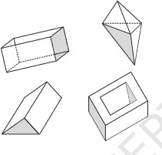

## Regular polyhedrons:

A polyhedron is said to be regular if its faces are made up of regular polygons and the same number of faces meet at each vertex.

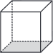

## Convex polyhedrons:

Convex Polyhedron is a polyhedron in which a line segment connecting any two vertices of the polyhedron contains only points that are on a face or inside the polyhedron.

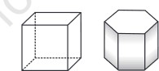

# Important polyhedrons:

## Prism:

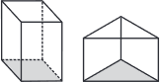

* + Prism is a polyhedron with two parallel opposite faces, called bases, that are congruent polygons and the lateral faces are parallelograms.
  + A prism is called a triangular prism if its ends are triangles.

## Pyramid:

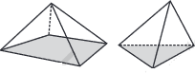

* + Pyramid is a solid whose base is a plane rectilinear figure and whose side faces are triangles having a common vertex, called the vertex of the pyramid.
  + A pyramid is said to be a regular pyramid if all the sides of its base are equal.
  + A pyramid is called a triangular pyramid if its base is a triangle.
  + A triangular pyramid is also called a tetrahedron.
  + If the base of a pyramid is a quadrilateral, then it is called quadrilateral pyramid.

# Euler's formula:

For any polyhedron: **F + V = E + 2**

where,

F = number of faces,

V = number of vertices, E = number of edges.